

Notifcation Blackout for Database and WebLogic
OEM 12C Version 12.1.0.2

Project



DISCLAIMER

This document is strictly private, confidential and personal to its recipients and should not be copied, distributed or reproduced in whole or in part, nor passed to any third party.

Version history
Date | Version | Description | Author
2019-07-17 | 1.0 | Initial Draft | Sharang Dwivedi
 |  | Reviewed
 |  | Approver

Contents
Version history 3
1. Introduction 4
2. Create notification blackout for weblogic server 5
3. Create notification blackout for Database 9

Introduction

This document will provide steps for creating notification blackout in OEM when Stopping/Restarting WebLogic and database. Creating notification blackout will help us to avoid unnecessary email notification maintenance period. Notification Blackouts only suppress the notifications on targets during the notification blackout duration.

Create notification blackout for weblogic server

2.1 Create Notification blackout for WebLogic server.

Login to OEM console and go to
Targets > Middleware

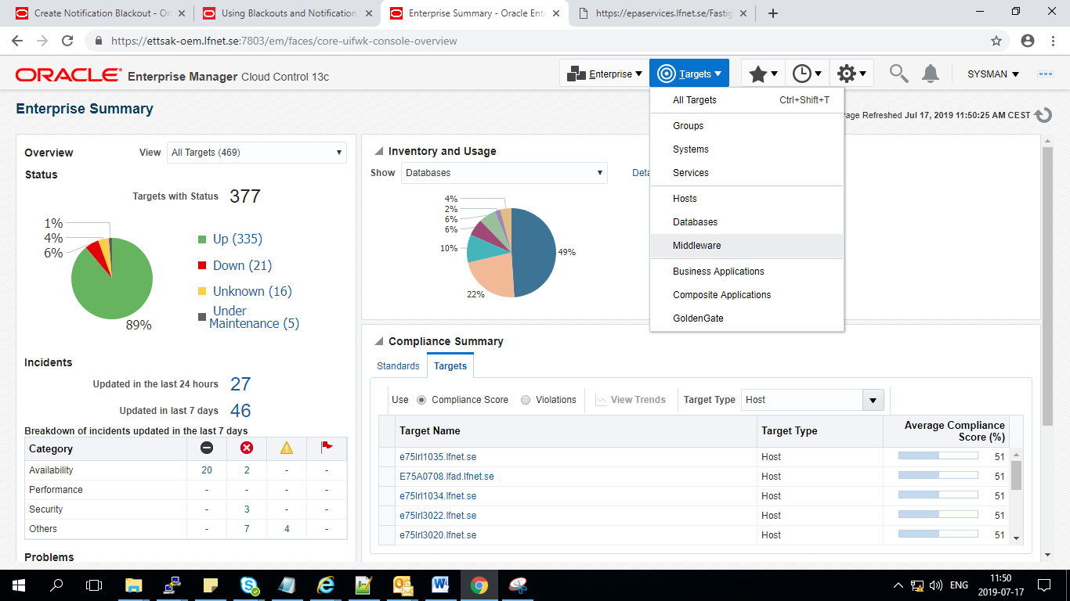

Select WebLogic server

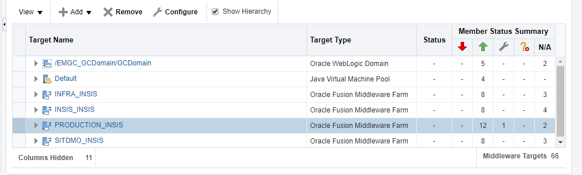

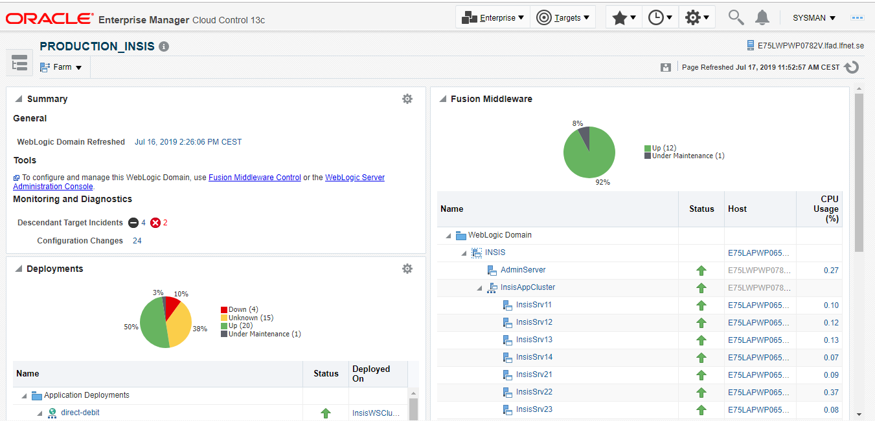

Navigate to Farm > Control > Create Notification Blackout

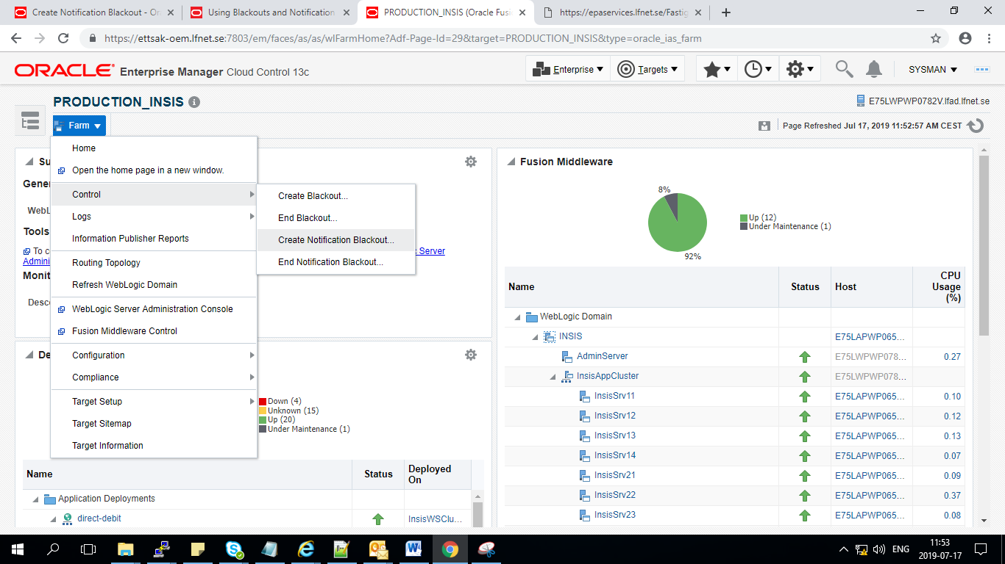

Provide name to notification Blackout

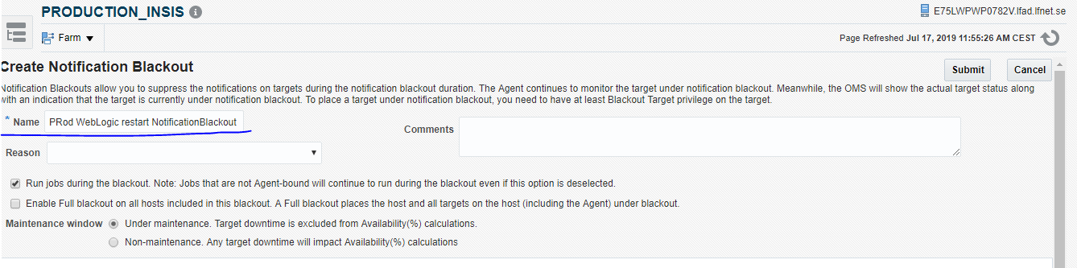

Schedule the notification blackout
Ex: below notification blackout has been created for 1 hour.

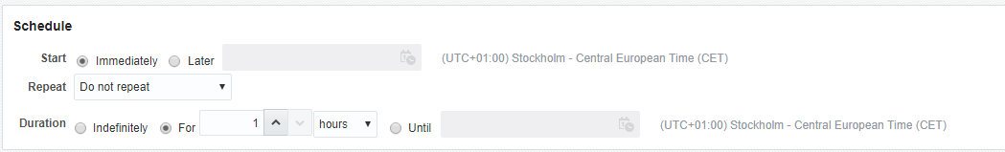

Submit the Notification Blackout
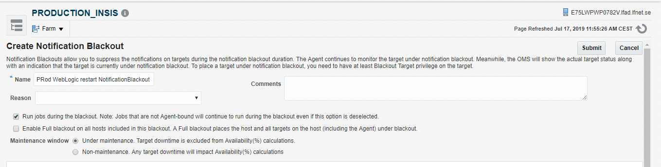

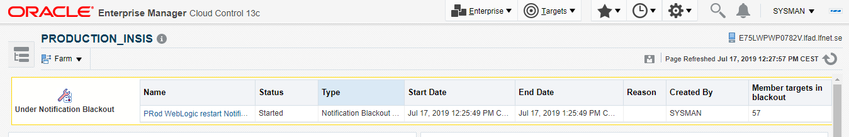

2.2 End Notification blackout for WebLogic server.

Farm > Control > End Notification Blackout

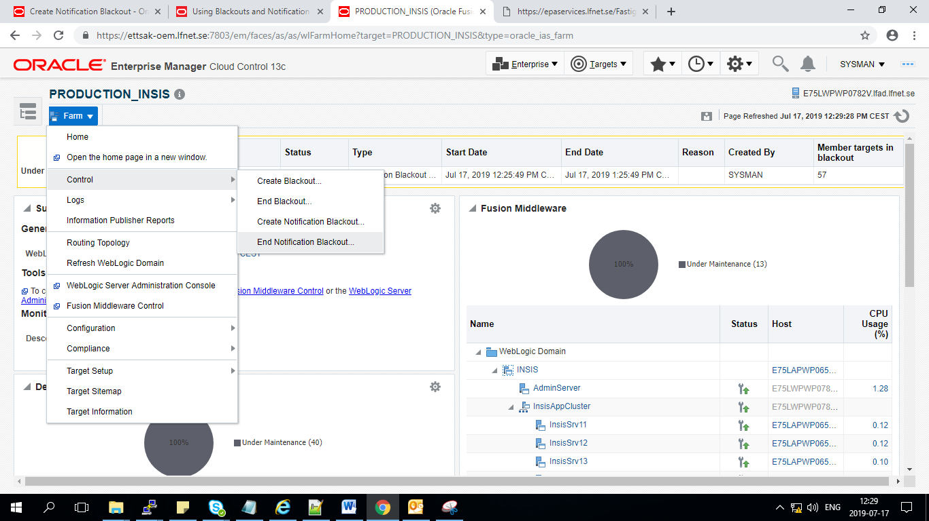
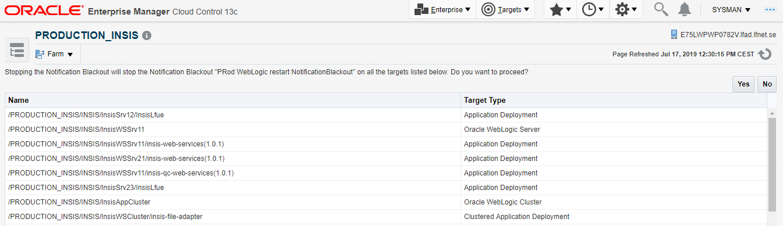

Notification Blackout successfully stopped
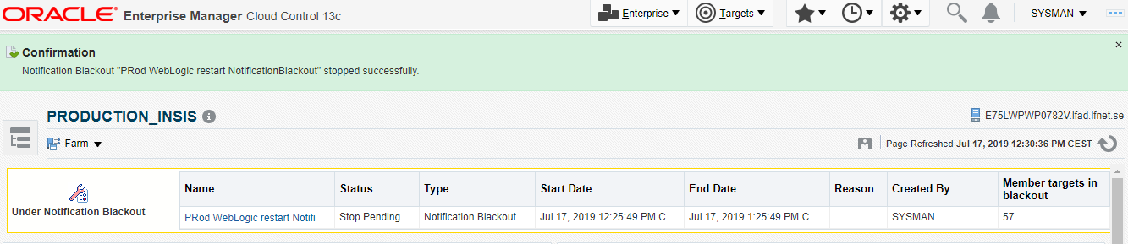

Create notification blackout for Database

2.1 Create Notification blackout for Database server.

Login to OEM console and go to
Targets > Databases
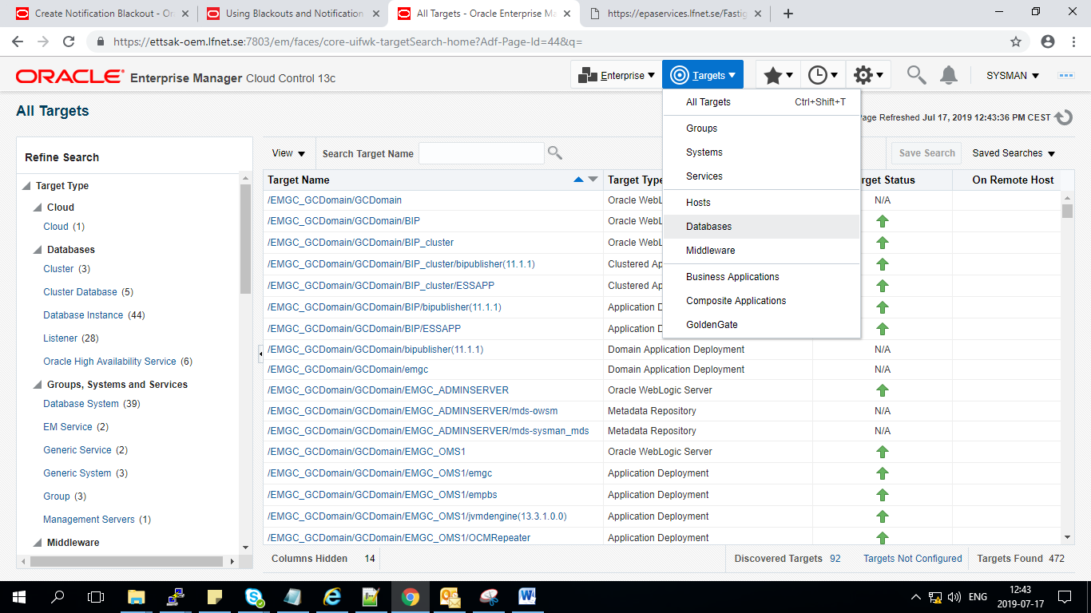

Select the target database
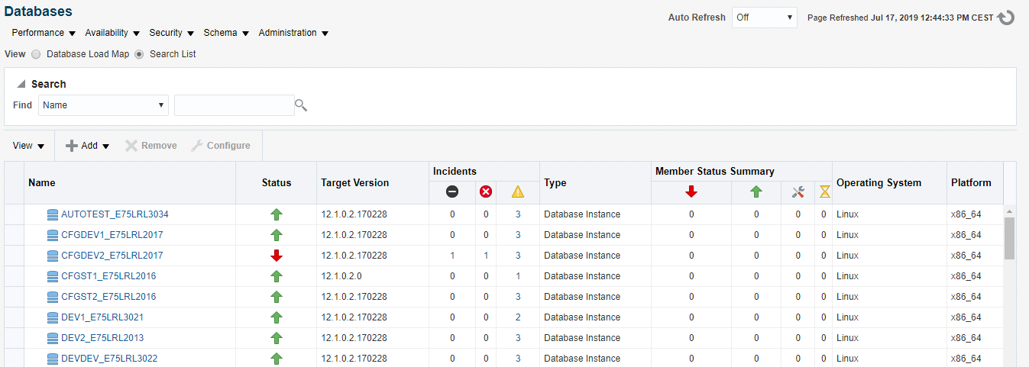

Selected AUTOTEST database as target
Navigate to Oracle Database > Control > create Notification blackout
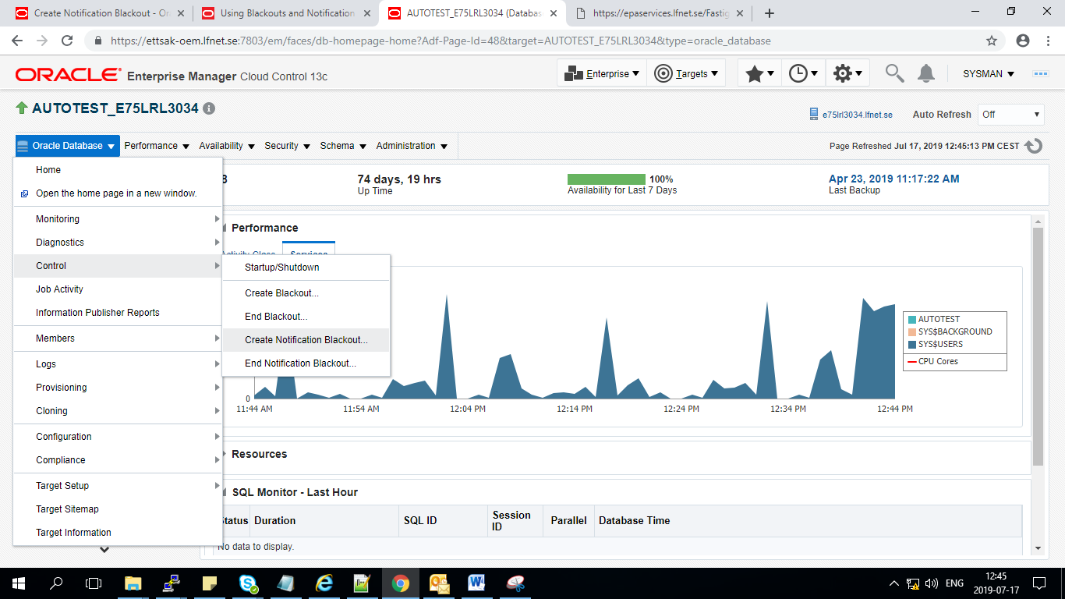

Notification blackout job name
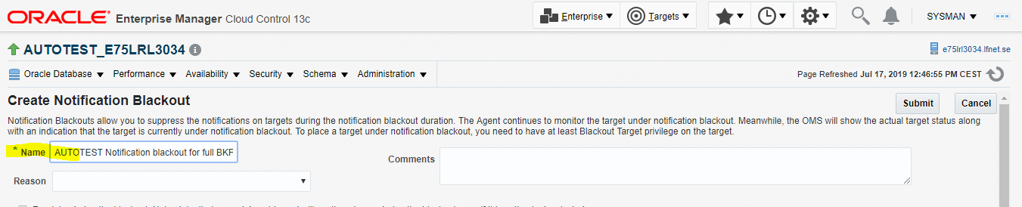

Schedule the notification blackout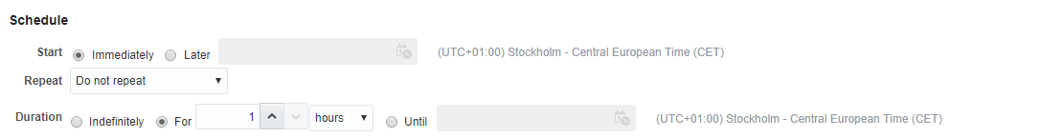

Notification blackout has been successfully created
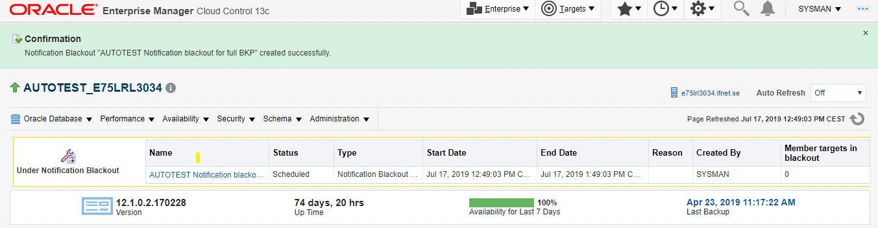

2.2 End Notification blackout for Database server.

Oracle Database > Control > End Notification Blackout
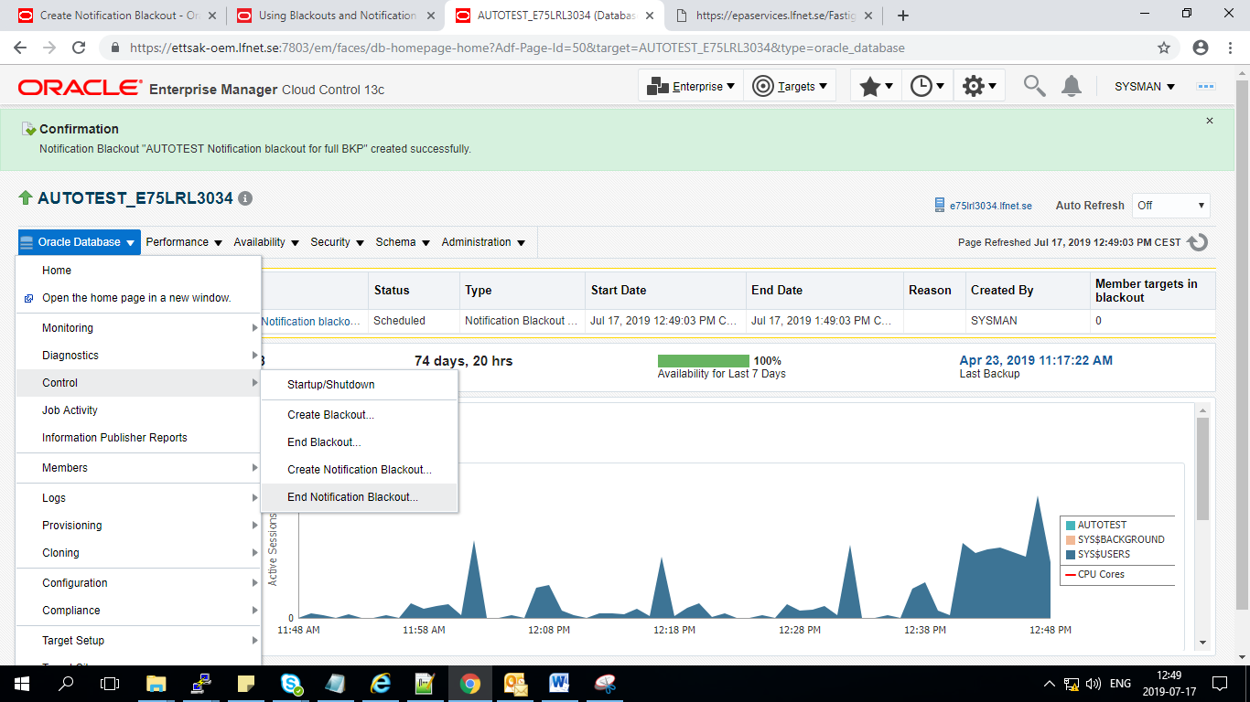

Confirmation
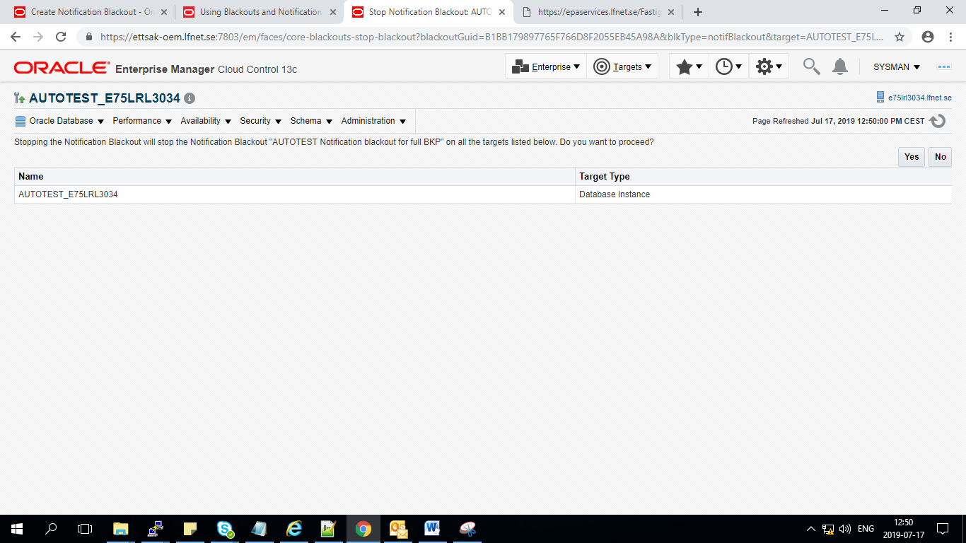

Notification blackout has been successfully completed

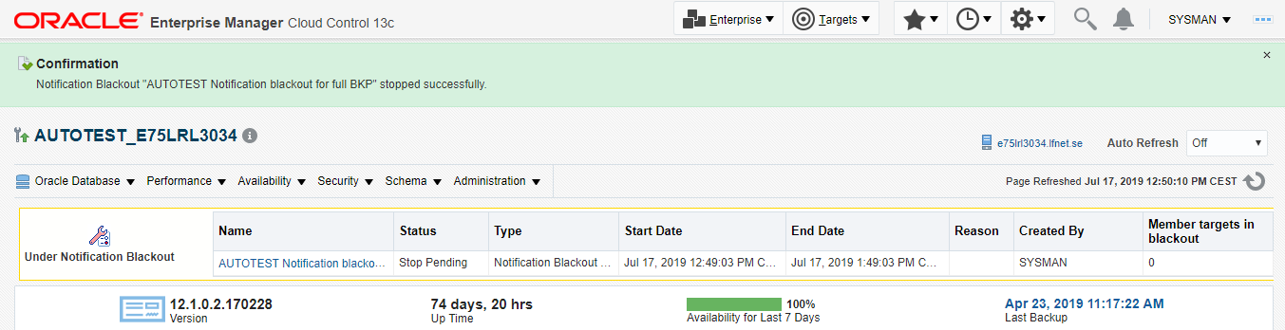

END OF DOCUMENT

